Table of Contents

CHAPTER l 1

INTRODUCTION 1

1.1 Introduction to E-commerce 1

1.2.1 Management 2

1.2.2 Information 2

1.2.3 System 2

1.3 Introduction to Store 4

CHAPTER 2 5

PLANNING 5

2.1 Introduction......... 5

2.2 The e-Commerce planning process 5

a) Identify the opportunity 5

b)Validate the opportunity 5

c)Channel planning 6

d)Develop experiences 6

e)Sell 6

f)Evaluate and optimize 6

2.3 Budget 6

2.4 Gantt Chart 7

CHAPTER3 8

NETWORK INFRASTRUCTURE 8

3.1 Network Infrastructure 8

3.1.1 Connecting to the Internet 9

3.l.2 Components of I-way: 9

CHAPTER4 10

PROCESS OF BUILDING WEBSITE 10

4.1 Process of website Building 10

4.1.1 For Live on Domain 10

4.1.2 Customer Account 10

4.1.3 Admin Dashboard Login 11

CHAPTER 5 12

PAYMENT GATEWAY 12

5.1 Payment Gateway 12

CHAPTER 6 13

HANDLING SECURITY ISSUE 13

6.1 Handle security issue 13

CHAPTER 7 14

SCREEN CAPTURE 14

7.1 Consumer Account Register and Login: 14

CHAPTER 8 15

CONCLUSION 15

8.1 Conclusion: 15

# CHAPTER l

# INTRODUCTION

## 1.1 Introduction to E-commerce

E-commerce means using the Internet and the web for business transactions and/or commercial transactions, which typically involve the exchange of value (e.g., money) across organizational or individual boundaries in return for products and services. Here we focus on digitally enabled commercial transactions among organizations and individuals.

E-business applications turn into e-commerce precisely, when an exchange of value occurs. Digitally enabled transactions include all transactions mediated by digital technology and platforn1; that is, transactions that occur over the Internet and the web.

E-commerce, short for electronic commerce, refers to the buying and selling of goods and services over the internet. It has become increasingly prevalent in modern society, revolutionizing the way businesses operate and how consumers shop. E-commerce encompasses a wide range of activities, from online retail stores to digital marketplaces, online auctions, and internet banking.

Moreover, e-commerce enables businesses to streamline logistics and fulfillment processes, optimizing inventory management and reducing operational costs. Advanced technologies such as automation and data analytic help businesses track inventory levels, forecast demand, and optimize shipping routes, ensuring efficient order fulfillment and delivery. This efficiency translates into improved customer satisfaction and loyalty.

An E commerce website is an information technology method in which traders, businesses/distributors/marketers can sell products/services and the customer can purchase on that website electronically by using the internet on the mobile and computer. It means an e-commerce website is an online shop. e means electronic. Commerce means business. Website means the group of HTML web pages and that is created to market/sell inforn1ation/product/services.

Some basics types of E-commerce are listed below:

• Business-to-Business. (B2B)

• Business-to-Consumer. (B2C)

• Consumer-to-Business. (C2B)

• Consumer-to-Consumer. (C2C)

**1.2 Introduction to MIS**

Management Information System or 'MIS' is a planned system of collecting, storing, and disseminating data in the form of information needed to carry out the functions of management.

The three components of MIS provide a more complete and focused definition, where System suggests integration and holistic view, Information stands for processed data, and Management is the ultimate user, the decision makers. Management information system can thus be analyzed as follows:

### 1.2.1 Management

MIS stands for Management Information Systems. In essence, it's a framework that utilizes a combination of technology, people, and business processes to manage data. Here's a breakdown of its core functions:

### 1.2.2 Information

Information, in MIS, means the processed data that helps the management in planning, controlling and operations. Data means all the facts arising out of the operations of the concern. Data is processed i.e. recorded, summarized, compared and finally presented to the management in the forn1of MIS report.

### 1.2.3 System

Data is processed into inforn1ation with the help of a system. A system is made up of inputs, processing, output and feedback or control.

Thus MIS means a system for processing data in order to give proper inforn1ation to the management for performing its functions. The major components of a typical MIS long-forn1 (Management Information System) are:

• **People** - people who use the information system

• **Data** - the data that the inforn1ation system records

• **Business Procedures** - procedures put in place on how to record, store and analyze data

• **Hardware** - these include servers, workstations, networking equipment, printers, etc.

• **Software** - these are programs used to handle the data. These include programs such as spreadsheet programs, database software, etc.

The Rise of E-commerce Pet Stores

Online shopping has become increasingly popular, and the pet industry is no exception. E-commerce allows pet stores to offer a seamless and personalized shopping experience for customers. This can include features like targeted promotions based on pet types, easy product browsing, and informative descriptions. This personalized approach fosters customer engagement and loyalty, ultimately driving sales growth. However, the pet e-commerce space has become quite competitive.

## 1.3 Introduction to Store

Located in Kathmandu, Pet Shop Nepal Us is your one-stop shop for all things pet. We offer a wide variety of products for your furry (or feathered, or scaled!) companions, including:

1. Dogs
2. Cats
3. Birds
4. Rats
5. Rabbits
6. And a wide range of pet accessories!

One of the biggest weaknesses of traditional, paper-based inventory management systems is the manual calculation of finances. This time-consuming process can hinder efficiency and make it difficult to track income accurately. Additionally, paper-based systems can slow down customer service, making it challenging to provide quick and efficient support.

# CHAPTER 2

# PLANNING

## 2.1 Introduction

The success of a strategy in ecommerce should be measured by the sales that are generated and ultimately profits made.... The most important thing is to have a strategy and to define this by setting and measuring ongoing targets and goals against your plan.

## 2.2 The e-Commerce planning process

Thee-Commerce planning process must have a six key steps that'll get you up and running with e-Commerce.

It covers the key skills, systems and sales know-how you need to drive e­

Commerce success.

a) Identify the opportunity

b) Validate the opportunity

c) Channel planning

d) Develop experiences

e) Sell

I) Evaluate and optimise

### a) Identify the opportunity

The first step of the e-Commerce planning process is to identity the opportunity. What benefit is e-Commerce actually going to have for your target audience and your brand? What e-Commerce insights do you have that make you confident you'll make money selling online?

You need to spend time defining the opportunity more specifically than just "sell online". That's too broad.

The move to sell online is similar to the decision to launch a new product.

### b)Validate the opportunity

So, once you've identified the opportunity, you need to test out if it is big enough to be worth pursuing. There's no single best way to do this. It very much depends on the size and nature of the opportunity. And your approach to opportunities and risks.

### c)Channel planning

Once you've identified and validated the overall e-Commerce planning opportunity for your business, it's now time to think about where you will sell Online.

### d)Develop experiences

This is where there are a series of steps consumers go through before they become loyal and regular purchasers.

So, they need to trust your brand, be aware of your brand, be persuaded to consider it and so on.

### e)Sell

Once you have all these elements of the e-Commerce planning process lined up, then your focus moves on to how to continue to sell your products Online.

### f)Evaluate and optimize

To setting up an online store and online retailers, we expand more on the day to day operations of online selling once you've gone through the e-Commerce planning process.

On-going, it's important to think like a retailer.

## 2.3 Budget

|  |  |  |  |  |
| --- | --- | --- | --- | --- |
| **S.N** | **Name** | **Pricin2** |  | **Duration** |
| 1. | Free Domain (.com.np) | Free | - | Life time |
| 2. | Top Level Domain (.com) | Rs.950 | | Yearly ( Renew) |
| 3. | Web Cloud Hosting | Rs.S000(Budget will increase during use of resources) | | Yearly renew |
| 4. | Maintenance | Rs.500 to 1000/hour | | Hour/ monthly |

## 2.4 Gantt Chart

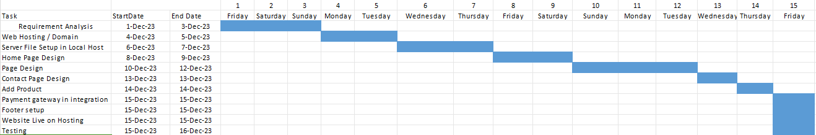

Fig:Gantt Chart

**2.5 Feasibility Analytics**

A feasibility analysis is a crucial step before building a website. It involves a thorough assessment of three key factors: practicality, market fit, and financial viability. By analyzing these factors, a feasibility analysis helps you decide if investing in the website is the right decision for your business.

Before building a website, a feasibility analysis is key. It helps assess if your website idea is practical, has a target market, and makes financial sense. In short, it's a check-up to see if your website is worth the investment.

# CHAPTER3

# NETWORK INFRASTRUCTURE

## 3.1 Network Infrastructure

The network infrastructure of E-commerce: Network infrastructure is required for e­ commerce to transport content. I-way is a high-capacity, interactive electronic pipeline used to transfer content in case of e-commerce.

I-way can transfer any type of context like, text, graphics, audio and video. In other words, multimedia contents are easily transported through I-way.

A network can be defined as:-

• Building block of E-commerce.

• Technologies to integrate Business Process

• Mediator for Digital transmission of Digital

• Content/Message/File/DATA

• The interaction between Entities of business

• like Supplier/Distributor/partner etc...

• A framework with security & ease.

World Wide Web

Motivation: Developing a global distributed hypern1edia system.

• Started 1989 by a research paper issued by Tim Berners-Lee who worked at the CERN.

• 1993: First usable browser (MOSAIC) issued.

• 1994: Foundation of World Wide Web Consortium (W3C).- W3C then started developing HTML, HTTP and Style Sheets.

Internet

The Internet is the entirety of all connected computers that use the package of internet protocols at their network systems' topmost layer. The collection of internet protocols implements a packet-oriented Wide Area Network for connecting networks of diverse protocols and different connection characteristics.

WWW

The World Wide Web (WWW) is a distributed hypermedia system that relies on some of the internet's services. Most important are the naming service provided by the Domain Name Service (DNS) and the - quite - reliable connection-oriented transmission service provided by the Transmission Control Protocol (TCP).

## 3.1.1 Connecting to the Internet

• **Dial-up Connection**: Computers that are serving only as clients need not be connected to the internet permanently. Computers connected to the internet via a dial-up connection usually are assigned a dynamic IP address by their ISP (Internet Service Provider).

• **Leased Line Connection**: Servers must always be connected to the internet. No dial-up connection via modem is used, but a leased line. Costs vary depending on bandwidth, distance and supplementary services. In these Given Network of internet easily to use and able no any issue will found while running the website.

• WPA

• 3G

• 4G

• 5G

## 3.l.2 Components of I-way:

- Consumer access equipment.

- Local on-ramps,

- Global information distribution networks.

Consumer access equipment are devices used by consumers to access the multimedia interactive contents of e-commerce. In this segment, hardware and software vendors are also included.

Local or access road, or on-ramps: This segment of I-way simplify linkages between businesses, universities, and homes to the communications backbone. There are four different types of provider of access ramps: - telecom-based - cable TV-based - wireless­ based and - computer-based online information services. These providers link users and e-commerce application providers.

Global inforn1ation distribution networks are the infrastructure that is connecting countries and continents

# CHAPTER4

# PROCESS OF BUILDING WEBSITE

## 4.1 Process of website Building

This online Shopping Websites is a Single vendor website, which is make on word press CMS Platfom1,

Some step of the Procedure of website building are as follow:

• First we install Xampp and WordPress installation file from www.wordress.org.

• Start MySQL andd Apache server,

• Setup the Wordpress in localhost, using WordPress setup file installation Process,

• Enter all details of database user name & Website Details Required While completion, Site Title, For Admin Dashboard login: Username, password, email, and site Description,

• We choose a free theme from WordPress theme platform and Activate Its,

• Activate the all required plugins for with initialize with theme Customize the design of front page.

• We install the also requirement the payment gate way plugins like esewa, Khalti for get payment.

• We customized the logo, add name of Categories of products and fill all details about products in Woo Commerce products section.

• Finally all complete the section of website and live on laptop

## 4.1.1 For Live on Domain

• We registered free domain from register.com.np

• And buy Hosting and install WordPress from c panel

• migrate the file of website having in Local host to c panel live server

• from using migration file tools,

• Then complete the Procedure,

## 4.1.2 Customer Account

Consumer can register a Account From Domainurl/my-account

## 4.1.3 Admin Dashboard Login

Adminstrator can able to login follow the web Uri yourdomainname/wp-admin

# CHAPTER 5

# PAYMENT GATEWAY

## 5.1 Payment Gateway

A payment gateway is an e-commerce application service which facilitates the sharing of relevant infom1ation between banks during an attempted credit or debit card transaction. It allows the appropriate information to be sent to the acquiring bank, and then collects a response from the issuing bank (whether the exchange has been approved or declined).

Generally, the service is needed by any business that wants to trade online and accept card payments from its customers. With the total value of B2C e-commerce sales currently standing at almost RS1.5 trillion per year - and major growth expected in the coming years - this group is likely to include the majority of commercial organizations.

In our e-commerce application have many different modes of payment. Some of the popular modes of payments system are as:

o E-sewa

o Khalti

o Bank transfer

o Debit card

o Cash on delivery

In our system we are included all types of payment method above and it is client user friendly for payment complete process.

# CHAPTER 6

# HANDLING SECURITY ISSUE

## 6.1 Handle security issue

In our website admin panel handles the security by different layer In any one try to login and access to in our admin panel must be

• Enter the correct username/ email and password which is stored in database and then after only can access,

• If username/ Email Id correct and password doesn't match from database unable to login

• Consumer also be the same process for login own dashboard panel for buy a Products.

# CHAPTER 7

# SCREEN CAPTURE

## 7.1 Consumer Account Register and Login:

**For Registering an account.**

While registering an account Need Username & Email address.

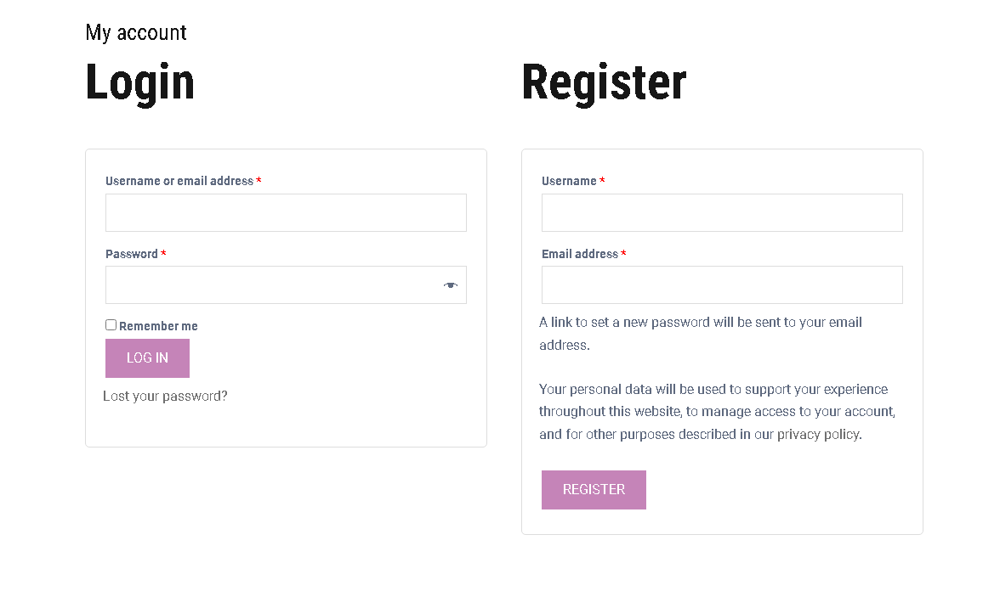

**For Login**

Consumer can Login own dashboard using Username/Email and Password.

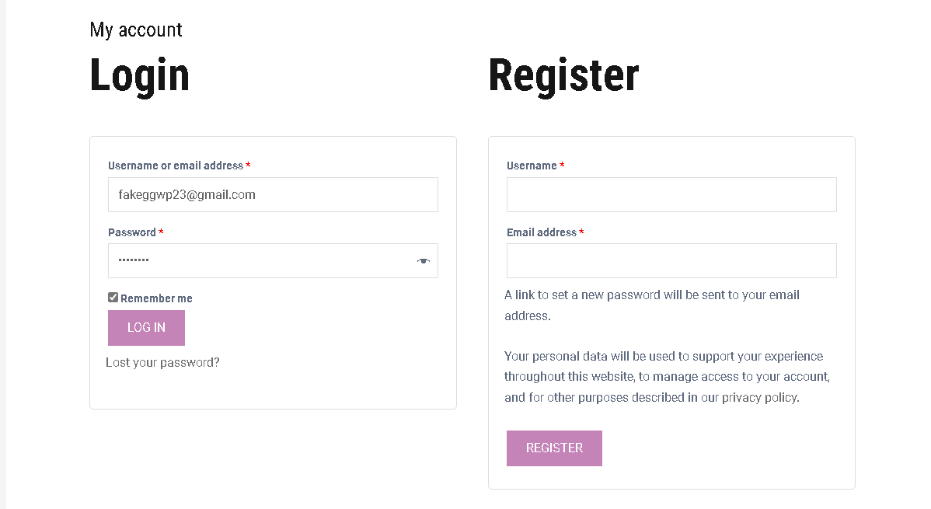

**My Account**

**Consumer Account Login Dashboard**

* Comsumer can saw all own orded details account and setup billing address from here

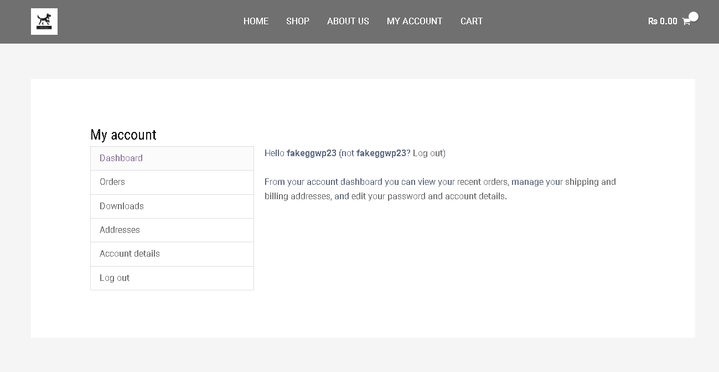

**Front Page**

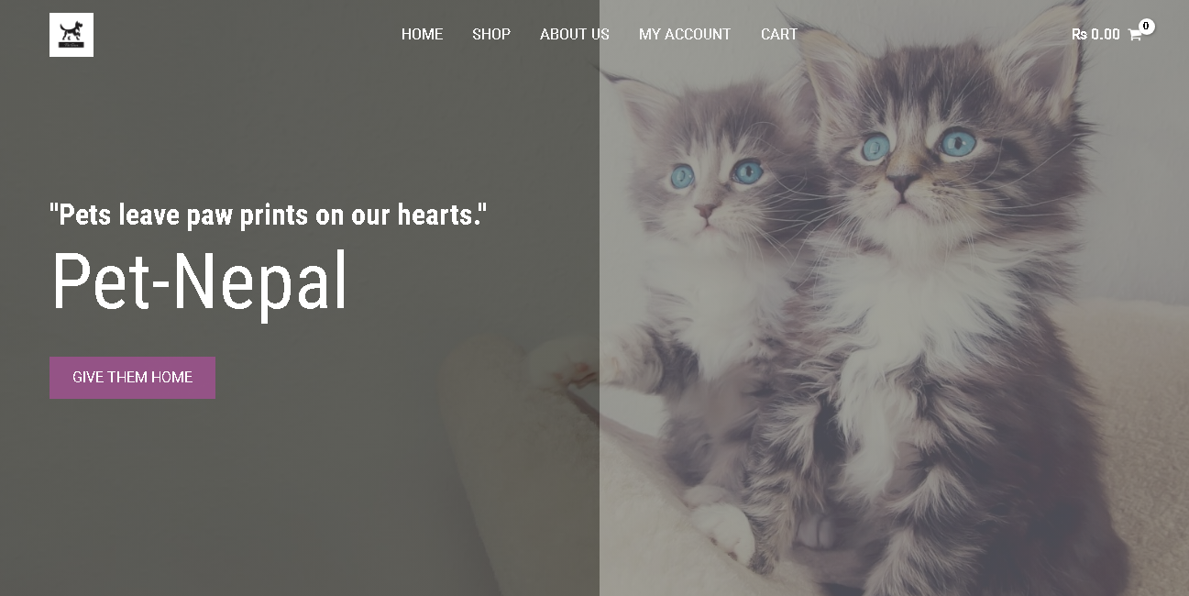

* Consumer can choose the products as own choice and added Products on add to cart.

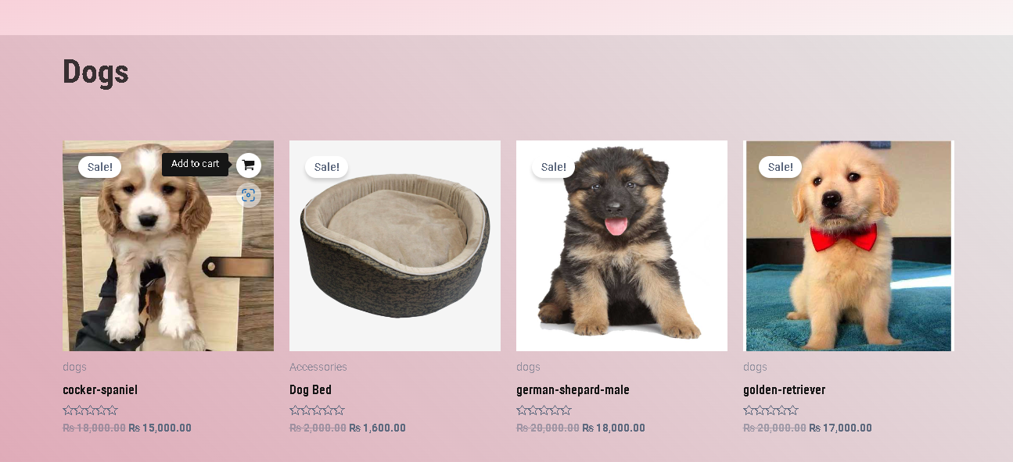

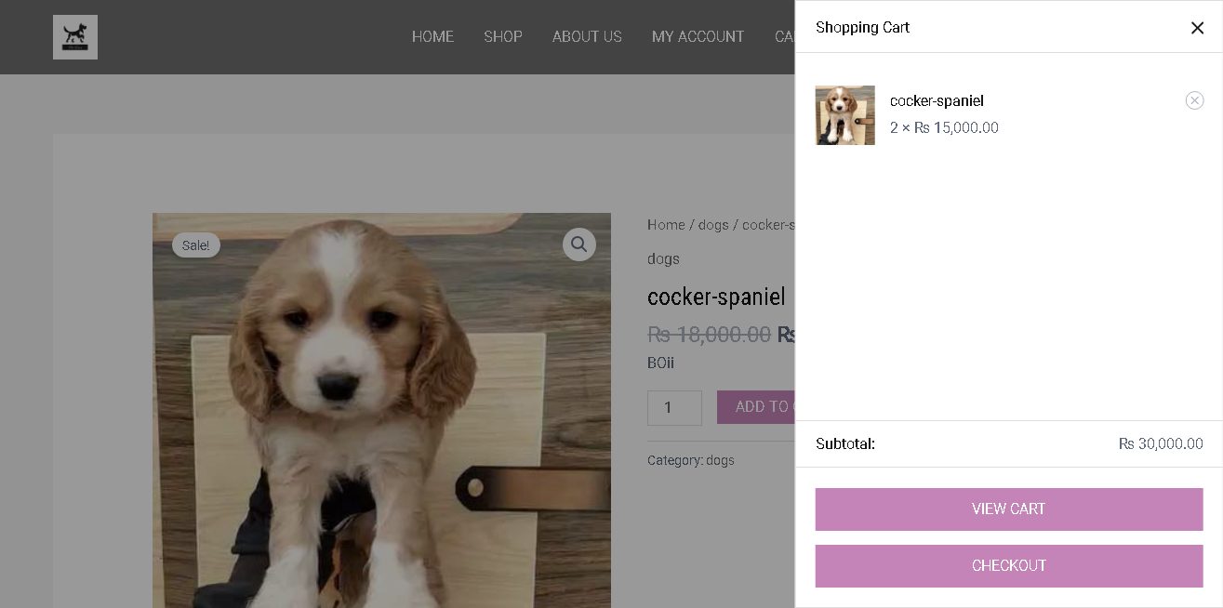

**Checkout**

For Check out need fill Form of Billing

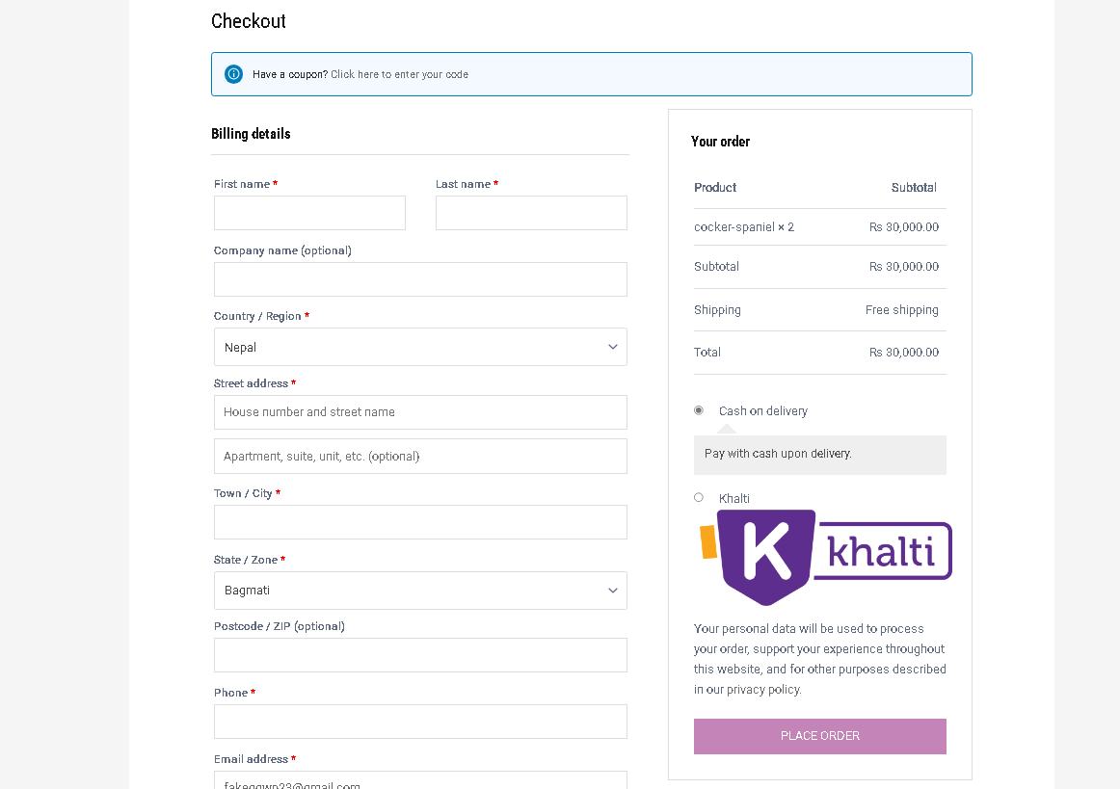

* Consumer must fill up the form correctly before complete the order.

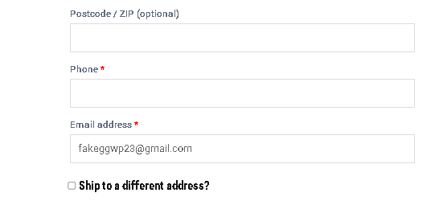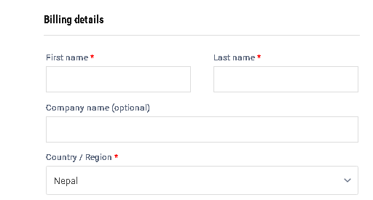

* 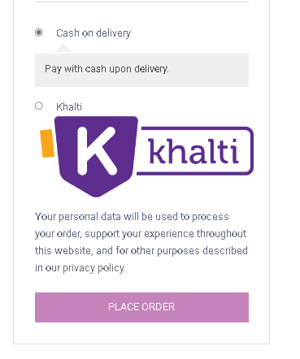You can see the ordered product details and choose the payment gateway as cash on delivery or Online (khalti).

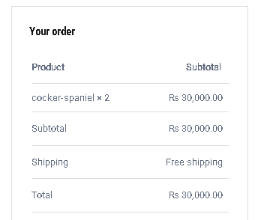

* Customer can also check the ordered product from dashboard.

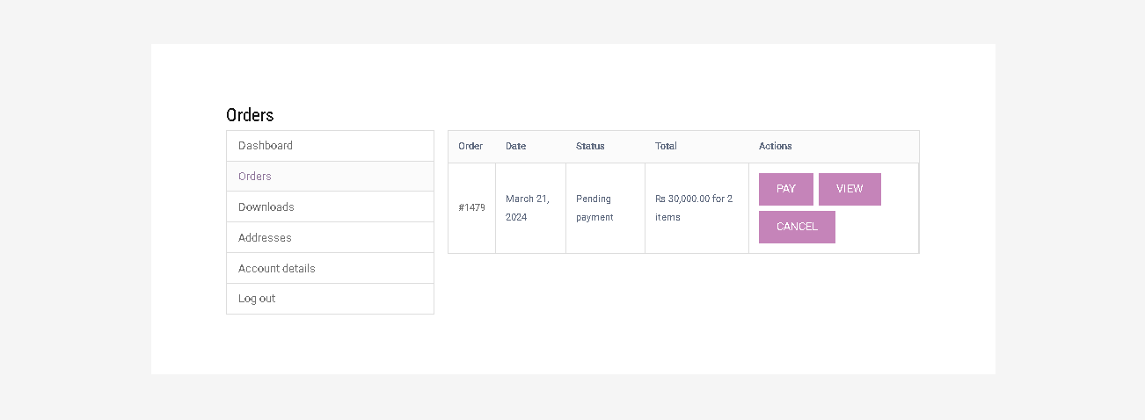

**Check Out**

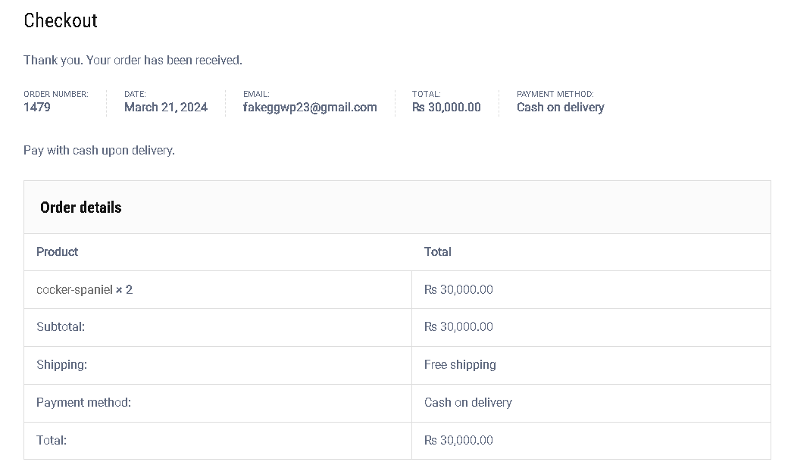

**Admin Login**

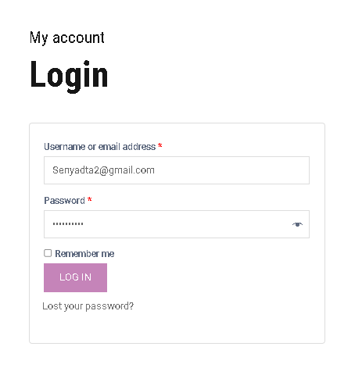

**Orders Detail received**

* Store staff can check order products from here
  + Go to woo Commerce and click on orders

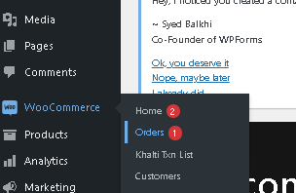

* The list of ordered received

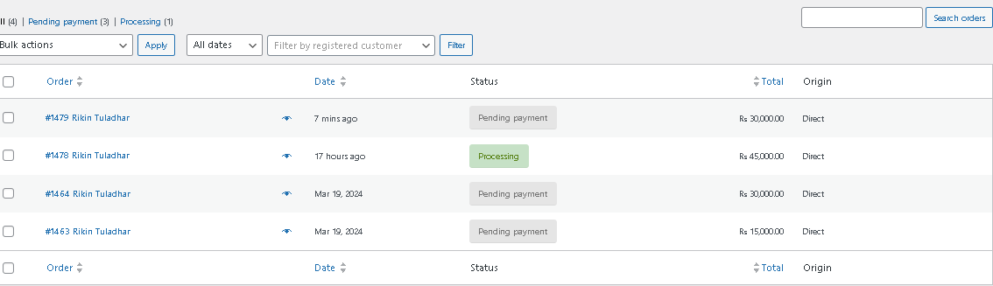

**Add products**

* Click on products from dashboard and Add New

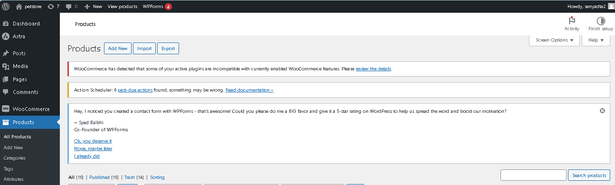

* Set the products name, description, image, categories, price

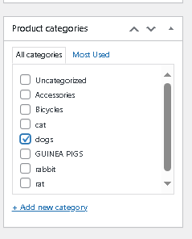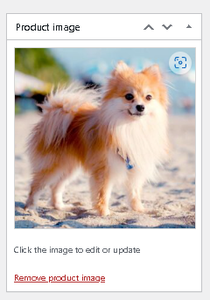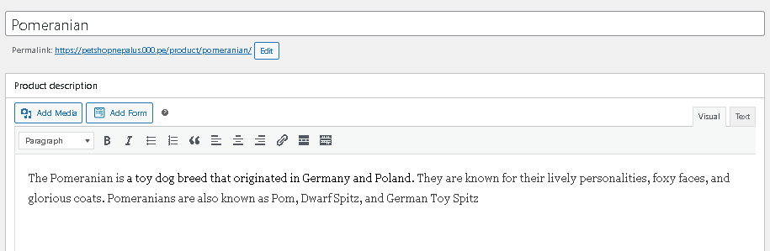

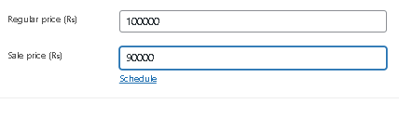

* This is the output of the product that was added.

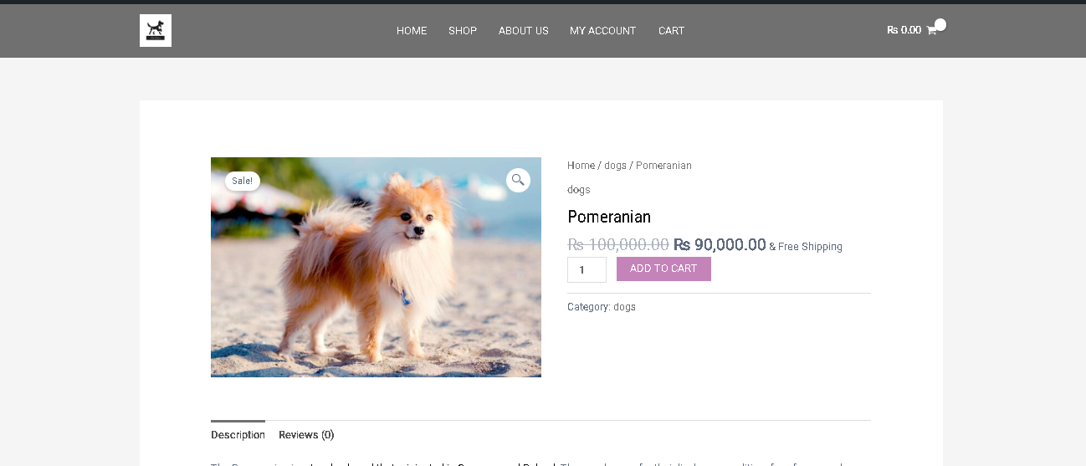

**Add payment gateways**

* Go to woo commerce settings from dashboard and click on payments

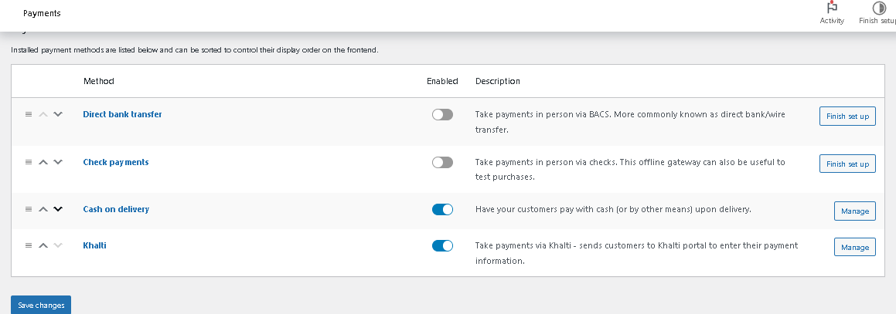

**Customers Details**

* Go to woo commerce from dashboard and click on Customers.

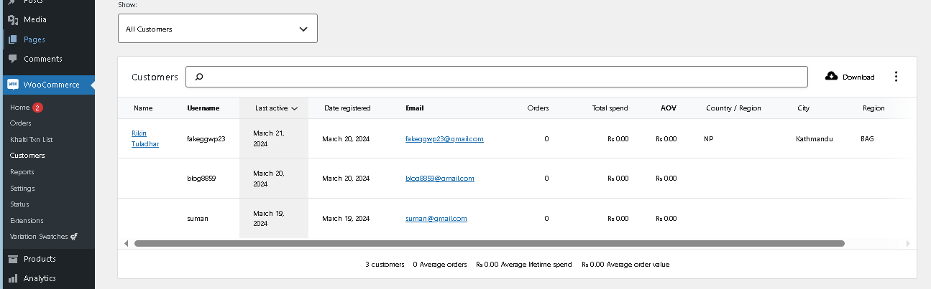

**Modify status of product’s order**

* Go to woo commerce from dashboard and click on orders.
* Modify the status and click update

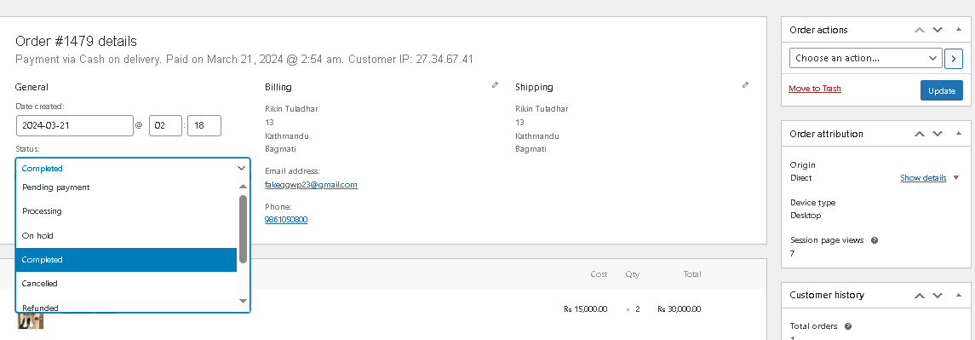

# CHAPTER 8

# CONCLUSION

## 8.1 Conclusion:

Overall ecommerce site consumer can buy the products which having in website. The Website, developed using WordPress CMS and PHP Language and MySQL Database is based on the requirement specification of the user and the analysis of the existing system, This ecommerce website is designed E-commerce online shopping is developed using WordPress theme PHP, CSS, Bootstrap, and JavaScript.

Talking about the Website, it has all the required essential features. This project has a user side where anyone can view product category and add products to cart and proceed for checkout and choose the payment gateway and also available cash on delivery system whereas from administration side Consumer can view product order, number of product, users,, add product and categories.

The user can also leave comments on each product if Consumer wants. In this project, all the main functions are perfom1ed from the Admin side user Friendly.